**P.SESHA HARSHINI**

**1NT19IS107**

**DT:10-05-2022**

**MAP REDUCE FUNCTIONS**

**AVERAGE:**

var map=function(){emit(this.name,this.age)};

> var reduce=function(name,age){return Array.avg(age);};

> db.names.mapReduce(map,reduce,{out :"newcollection"});

> db.newcollection.find()

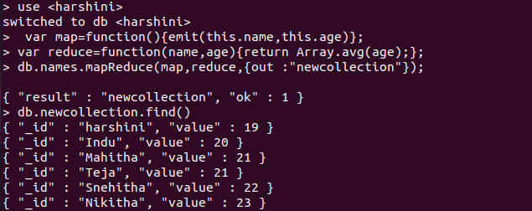

**SUM:**

> var map=function(){emit(this.name,this.age)};

> var reduce=function(name,age){return Array.sum(age);};

> db.names.mapReduce(map,reduce,{out :"newcollection"});

> db.newcollection.find()

